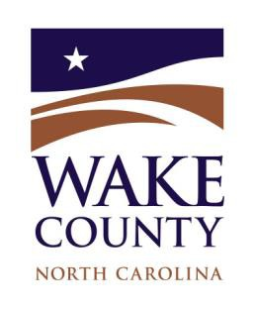
Wake County Water Partnership
Meeting Minutes
Friday, October 10, 2025
1:00 pm -4:00 pm
Gipson Play Park and Trophy Brewing Tour
Committee Members Attending: Daniel Wiebke, Chair; George Matthis, Vice Chair; Jeff Adkins; Nancy Daly; Leah Harrison; Marc Collins; Lisa Booze; Emily Bateman; Lori Avent; Ed Buchan; Donna Myers

Wake One Water focuses on maximizing the value of all forms of water so that we are

better prepared to support all aspects of our growing population, while preserving our limited

natural resources. Our tour will include visits to two sites that are helping advance One

Water goals through innovative stormwater management and implementation of best

business practices.

#1 Meeting Location: Gipson Play Park, 801 Biggs Dr., Raleigh, NC 27603

Gipson Play Plaza at Dorthea Dix Park 1:00

Dean Perry, AICP, ASLA, Senior Planner-Dix Park

Tour included a demonstration of innovative stormwater management features incorporated into the Gipson Park Play Plaza. The park integrates natural features including more than 1,000 trees and includes educational signage to engage both children and adults in learning. Key stormwater features include:

Underground storage used for irrigation

60% native/native adapted species; no invasives

Bioswales installed in parking lot

Supporting factors contributing to Raleigh’s GSI implementation:

Stormwater Management Advisory Commission

GSI policy adopted in 2023: lead by example

Two GSI advocates located in plan review

GSI visibility is a priority

GSI Maintenance Team

Raleigh is developing a GIS Master Plan that will help prioritize projects.

Future project: Rocky Branch stream restoration project.

Travel to Trophy Brewing 2:15

#2 Meeting Location: Trophy Brewing, 656 Maywood Ave., Raleigh, NC 27603

Trophy Brewing 2:30

Les Stewart, CBO & Co-Owner of Trophy Brewing Company

Tour included an overview of Trophy Brewery with a focus on the importance of high quality water in the brewing process. Discussion included business best practices such as sustainability, coordination with water providers, and increasing the public’s awareness of water. Key takeaways linked to One Water include:

Importance of water quality. Low mineral profile of Raleigh Water is beneficial to brewing process.

Trophy distribution is limited within the Triangle to minimize carbon footprint.

Trophy Brewing and Wake Tech collaboration on brewing workforce and training.

Recent collaboration with Raleigh Water to produce canned sparkling water.

Closing Remarks 3:45

Adjourn 4:00

